Web Application Security Report
Task: Introduction to Web Application Security
Name: SALMA AHMED
Target URL: http://testphp.vulnweb.com Environment: Kali Linux, Firefox
Tools Used: OWASP ZAP, sqlmap, Burp Suite

Objective
The objective of this task is to learn about common web application vulnerabilities by analyzing an intentionally vulnerable website. The focus is on identifying, exploiting, and understanding SQL Injection, Cross-Site Scripting (XSS), and Cross-Site Request Forgery (CSRF).

Vulnerability Findings

SQL Injection
    - Discovery: Identified via sqlmap scan on artist.php parameter.

Proof of Concept (PoC):
sqlmap -u "http://testphp.vulnweb.com/artists.php?artist=1" --dbs

output:
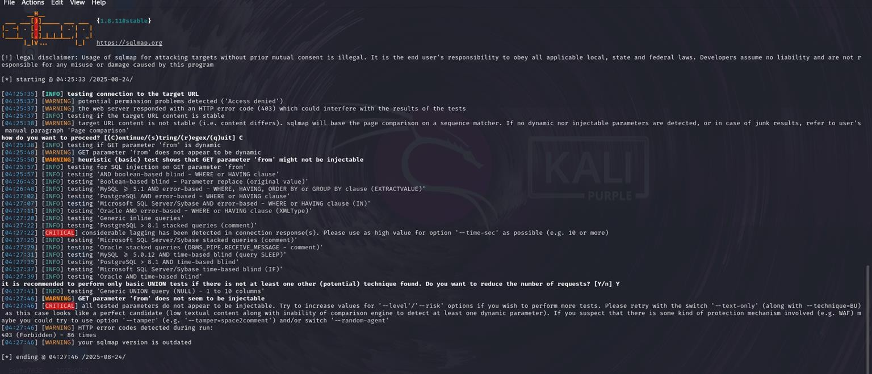
    - ​
    - Impact: Attackers can extract sensitive data, bypass authentication, or manipulate the database.
    - Mitigation: Use parameterized queries (prepared statements) and input validation.

Cross-Site Scripting (XSS – Stored)
    - Discovery: Found in guestbook.php input field.

Proof of Concept (PoC):
<script>alert('XSS')</script>

output:
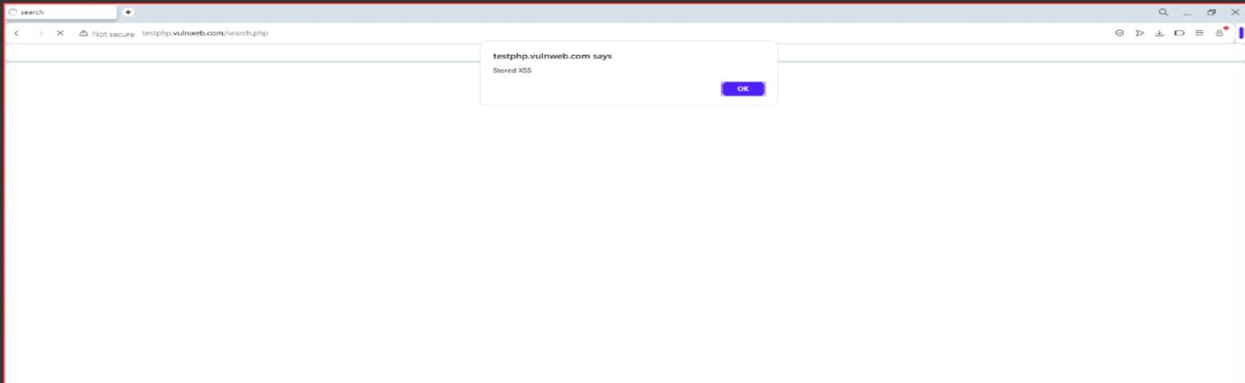
    - ​
    - Impact: Attackers can steal cookies, hijack sessions, or deface content.
    - Mitigation: Implement input validation, output encoding, and use Content Security Policy (CSP).

Cross-Site Request Forgery (CSRF)
    - Discovery: Captured cart manipulation request in Burp Suite, replayed without CSRF token.
    - Proof of Concept (PoC): Malicious HTML form crafted to change user’s cart. GET /cart.php?add=1
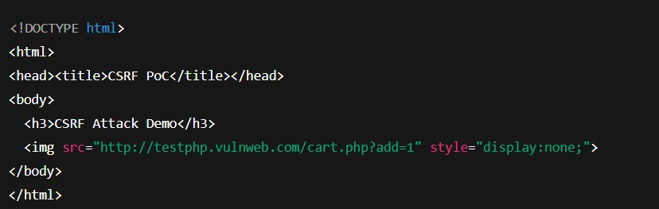

    - Impact: Attackers can trick users into performing unintended actions (e.g., altering cart items).
    - Mitigation: Use CSRF tokens in forms, enforce SameSite cookie attributes.

Conclusion
The analysis of testphp.vulnweb.com confirmed the presence of common vulnerabilities: SQL Injection, Stored XSS, and CSRF. Each of these flaws could allow attackers to compromise data integrity, confidentiality, or user trust. Applying secure coding practices, proper input handling, and security headers are essential for mitigating these risks.

